Chapter 7

Measuring the Barrier Height of the CdTe Back Contact

Introduction
Making low resistance (i.e. Ohmic) back contacts for CdTe cells is one of the major barriers to improving the efficiency of these devices. Although high back contact barrier height affects neither V_{oc} nor J_{sc}, it deteriorates FF and, therefore, the η [1, 2]. This can be understood by considering that the back contact increases R_{s}. As a result, the slope of the J-V curve in the forward bias changes (i.e. becomes less steep) and reduces the “squareness” of the curve i.e. reduces FF.
It is discussed in Section 2.1 that creating an Ohmic contact (i.e. low resistance contact) to a p-type semiconductor requires that 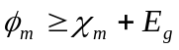. In the case of CdTe, _{m} and E_{g} are 4.5 eV and 1.4 eV respectively [3], which means that in order to form a low resistance contact to p-type CdTe the metal work function must be 5.9 eV. Such a metal does not exist. Hence, it is necessary to find alternative methods to overcome this issue. These methods can be categorised in general as follows [4]:
- Creating a tunnelling contact by heavily doping the back surface of the semiconductor to produce a p⁺-type layer between it and the metal. This behaviour is explained in Section 2.1.
- Changing the stiochiometry of the semiconductor surface (to Te-rich in the case of CdTe cells) by etching, which leads to the same effect.
- Introducing a highly conductive p-type semiconductor (which can be contacted more easily with metals) with high electron affinity and low E_{g} on the back surface of the cell.

Measuring the back contact barrier height _{b}
Five methods of measuring the back contact barrier height for CdTe solar cells are discussed in this Section and two of these were selected for use in experiments. Most, but not all of the methods use J-V-T data.

Method I
Bätzner et al. [5] measured R_{s} of a solar cell as a function of T. The authors proposed that R_{s}(T)can be separated into a) an Ohmic part, and b) an exponential part resulting from passage of the carriers over the back contact barrier by thermoionic emission. As a result, R_{s} is expressed as

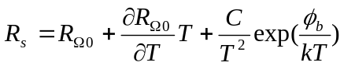 (‎7.1)

where 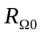 and 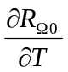 are the Ohmic resistance and its temperature coefficient respectively, C is a fitting parameter, k is the Boltzmann constant and _{b} is the back contact barrier height. Fitting of R_{s}(T) to this equation was used to determine _{b} in [6] and [7].

Method II
Stollwerck and Sites [1] measured the barrier height by proposing the two-diode model, which assumes the back contact and main junctions as two separate diodes. This assumption is valid when the total thickness of absorber layer is larger than the sum of depletion regions for both main and back junctions. These two diodes are connected back-to-back to each other. Furthermore, the back diode was assumed to be both partially shunted and light insensitive.
The procedure of the above method is to fit the experimental J-V data to equation 2.10 (including the light generated current J_{L})

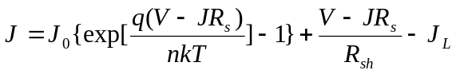 (2.10)

The fit was performed [1] by using the experimental values of J and then calculating V for each data point. The difference between experimental and calculated values of V is called ΔV, which was assumed to be the voltage drop across the back contact. ΔV was then fitted to the equation

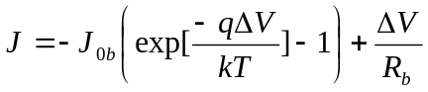 (‎7.2)

where

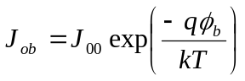 (‎7.3)

and

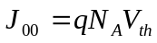 (‎7.4)

where J_{0b} is the saturation current for the back diode, R_{b} is the shunt resistance of the back diode, _{b} is the back contact barrier height, N_{A} is the doping concentration of the absorber layer in the solar cell, V_{th} is the thermal velocity and the rest of symbols have their usual meanings. It is seen from equation 7.3 that _{b} can be evaluated from the semi-log plot of J_{0b} versus 1/T.

Method III

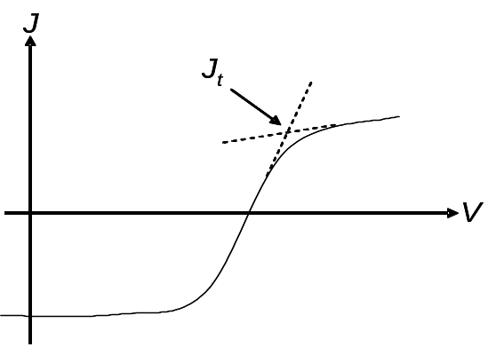

Figure ‎7.1: A J-V curve showing roll-over effect. The dashed lines represent the linear extrapolation by which J_{t} is determined.

Koishiyev et al. [8] used the same two-diode model to evaluate the barrier height of the back contact. In this method, the value of J in which J-V curve starts to roll-over was called the turning current J_{t}. J_{t} was determined as the intercept of two straight lines which are the resultants of linear fits to the data before and after roll-over in the J-V curve, as shown in Figure ‎7.1. J_{t} was considered as the saturation current for the back contact diode J_{0b}, which is given by

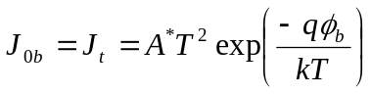 (‎7.5)

where A* is the Richardson constant and the rest of symbols have their usual meanings. The experimental data of J_{t} versus T were fitted to equation 7.5 with both A* and _{b} being adjustable parameters. The fits are relatively insensitive to the values of A* used, and choosing reasonable estimates for both parameters allows a solution to be converged upon rapidly.

Method IV
McCandless et al. [9] also used the two-diode model to develop a method for measuring the barrier height. Furthermore, R_{s} was assumed to be the sum of a) back contact resistance R_{c}, and b) a temperature-independent lumped resistance R₀.

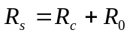 (‎7.6)

The back contact diode current J_{c} is expressed as

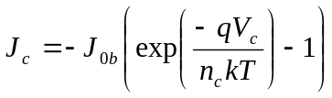 (‎7.7)

where

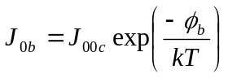 (‎7.8)

J_{00c} is a constant, V_{c} is the voltage across back contact and n_{c} is the ideality factor for back contact. If 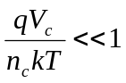, then equation 6.7 can be rewritten as

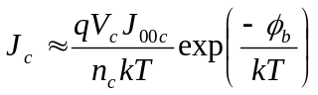 (‎7.9)

By using equations 7.6 and 9.9

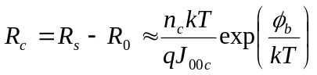 (‎7.10)

It is seen from equations 7.8 and 7.9 that J_{0b} = ∞ when T = ∞ i.e. R_{c} ≈ 0 at high T. This means that the approximation that R₀ ~ R_{s} is valid at high T, and so R₀ is determined this way. After measuring R_{s} at various T, _{b} can be determined from plotting R_{c} versus 1/T (equation 7.10).

Method V
Demtsu and Sites [10] measured _{b} by using Method III. However, the barrier height was determined from a single J-V curve at room temperature by solving equation 7.5 analytically. Moreover, the authors simulated the J-V curve by generating it analytically as follows: J_{m} and J_{b} are the current densities across main and back junction respectively, and they can be expressed as

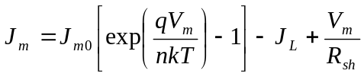 (‎7.11)

and

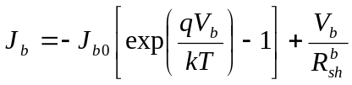 (‎7.12)

where J_{m0} is the saturation current density for main junction, V_{m} is the voltage drop across main junction, R_{sh} is the shunt resistance of main junction, J_{b0} is the current density of back junction, V_{b} is the voltage drop across back junction, 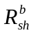 is the shunt resistance of back junction and the rest of symbols have their usual meanings. Since the same current passes in both junctions, equations 7.11 and 7.12 give

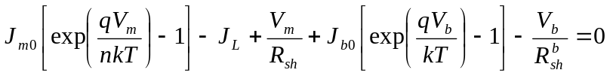 (‎7.13)

The values of J_{m0}, n and R_{sh} are obtained experimentally [10]. Equation 7.13 was solved analytically, and the resulting data were fitted to the experimental J-V characteristics in order to obtain other parameters. The value of the back contact barrier height estimated from this fitting was comparable to that obtained analytically (as explained above).

Of the five methods discussed above, Methods I and III were selected for use in the present work. Firstly, both of these methods do not suffer from the difficulties in implementation of the others. For example, Method II requires accurate values of both R_{sh} and R_{s} in order to perform correct fitting to equation 2.10. Additionally, this method requires data fitting three times in order to determine _{b}, which increases errors. In Method IV it is assumed that R_{s} = R₀ + R_{c}, where R_{c} = 0 at high T. However, the temperature at which this approximation becomes valid is not known with any certainty. In Method V, the direct fitting of J-V curves demands accurate knowledge of a number of unknown variables which must be determined from other experiments. On the other hand, Method I is a self-contained fitting procedure for R_{s} versus T that may be applied to any cell device. Method III utilises the roll-over of J-V curves that is known to be a consequence of the back contact barrier itself. Moreover, Methods I and III invoke different physics for the analysis, and hence provide an interesting comparison of methods for determining _{b}. This is explored in the preliminary study presented in Section 7.3.

Preliminary study to test the validity of two different methods measuring _{b}

Introduction
_{b} was evaluated by two different methods, Method I and Method III, in order to examine the validity of these tests by comparing their values with each other. The approach is completely different in each method as explained in Section 7.2. While Method I relies on the dependence of R_{s} on T, Method II determines _{b} by considering the roll-over behaviour in J-V characteristics at a range of T i.e. J_{t} versus T.
In this work Method I (Bätzner et al. [5]) was modified slightly. While Bätzner used a three term fit to the temperature dependence of R_{s}, as shown in equation 7.1, this was re-evaluated here using the data in ref. 5. While the second (linear) term in 7.1 dominates at high temperature, the third (exponential) term dominates at low temperatures. Hence for data recorded at T 300°C – as in the experiments that follow – it is valid to approximate equation 7.1 as

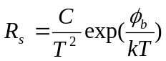 (‎7.14)

Equation 7.14 is therefore used instead of 7.1 for the rest of this work.
The second method used here (Method III) depends on locating the turning point of the J-V curve in order to identify a current value J_{t}. While Koishiyev [8] achieved this by extrapolation, in this work the differential plot dJ/dV versus V was used as shown in Figure ‎7.2b. This has the advantage that the turning point may be established from curves for which the roll-over effect is weak, as shown in Figure ‎7.2a and b. J_{t} is therefore easier to distinguish using this method than by extrapolation. This method also has the advantage that the voltage associated with the turning point itself is accurately identified, whereas the intercept method used in reference 8 leads to a slight systematic over estimation of this value.

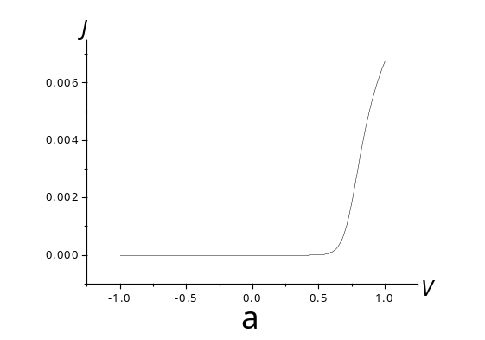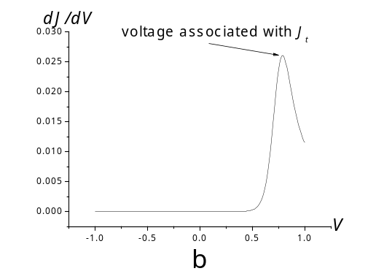

Figure ‎7.2: a) A normal J-V curve showing a slight roll-over effect. b) dV/dJ vs. V for the same data in (a) showing a clearer turning point i.e. J_{t}, which was used to determine _{b}.

It is important to note that only dark J-V-T data were considered to determine _{b}. This eliminates illumination-induced changes such as heating and possible changes in light intensity. Moreover, it has been reported that there was no variation in _{b} values extracted form both dark and light J-V-T [11]. This behaviour agrees with the assumptions of the two-diode model i.e. that diodes are independent and that the back diode is light insensitive. Light is not expected to reach the back contact for cells investigated in this work since CdTe thickness for all devices studied varied in the range of ~ 2.3 – 8 µm, and so visible light will be completely absorbed before reaching the back contact.

Experimental

Sample fabrication
The samples investigated in this part were the same samples studied in Chapter 6 i.e. the samples for which the current transport mechanism was investigated. For details of the growth and processing the reader is referred Section 6.2.1 while a summary of the samples components is given in Table 6.1. The principal difference of relevance to this Chapter is that sample 290 was CSS-grown and has an Au/N-P etched contact while samples 254 and 305 are MOCVD-grown and have Au/CdTe:As⁺ contacts. The contact types are listed along with the barrier height results in Table ‎7.1.

J-V-T measurements
The dark J-V-T data obtained in Chapter 6 were used again in this Section. Only dark J-V-T data were considered as discussed above. R_{s} obtained from the slope of J-V curves under forward conditions (Method A in Appendix A) for Method I. J_{t} values were determined as explained in Section 7.3.1 for measuring _{b} using Method III.

Results and discussion for the preliminary study
Figure ‎7.3 shows plots of R_{s} versus T for samples 290, 254 and 305. Fitting of these plots using Method I allowed extraction of values for the barrier height _{b}. Figure ‎7.4 shows J_{t} versus T for the same cells, with _{b} being extracted using Method III. The results obtained from both methods are compared Table ‎7.1.

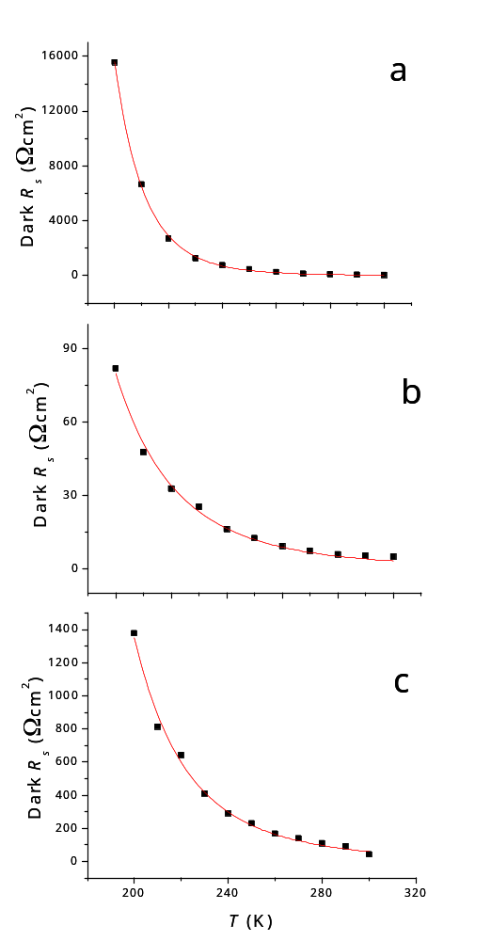

Figure ‎7.3: R_{s} versus T curves used to determine _{b} using Method I as described in Sections 7.2 and 7.3.1. a) sample 290, _{b} = 0.28 eV, b) sample 254, _{b} = 0.13 eV and c) sample 305, _{b} = 0.12 eV.

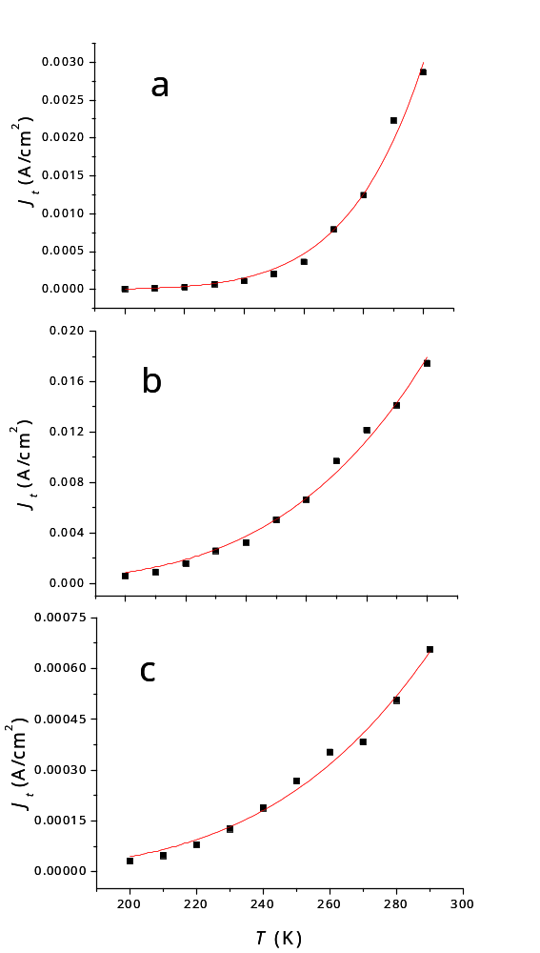

Figure ‎7.4: J_{t} versus T curves used to determine _{b} using Method III as described in Sections 7.2 and 7.3.1. a) sample 290, _{b} = 0.26 eV, b) sample 254, _{b} = 0.12 eV and c) sample 305, _{b} = 0.11 eV.
Cell | Contact | Barrier height _{b} (eV)
Cell | Contact | Method I | Method III
290 | 2 mm dot Au/etched back surface | 0.28 | 0.26
254 | 2 mm dot Au/CdTe:As⁺ | 0.13 | 0.12
305 | 5×5 mm square Au/CdTe:As⁺ | 0.12 | 0.11

Table ‎7.1: The values of _{b} extracted by using Methods I and III for samples 290, 254 and 305.

It may be seen from the table that for each sample, Methods I and III yield barrier heights that agree to within ± 0.01 eV, this level of agreement being observed for samples with the lowest (~ 0.12 eV) and highest (~ 0.027 eV) barriers. This degree of agreement implies that either of the two methods may be used to give a comparable result. Moreover, since the two methods agree, even though the physical basis is each is different, this gives some confidence that both are giving a genuine measurement of the barrier height (This being despite slight modifications having been applied to both methods).
The fact that samples 254 and 305 had identical Au/CdTe:As⁺ back contacts, which differed only in their size (254, 2 mm circular dot; 305, 5×5 mm square dot) allows further conclusions to be drawn about Method I. In particular since the series resistances of the two contacts differed in value by a factor of ~ 17 (see Figure ‎7.3 b and c), but the barrier heights nevertheless agree to ± 0.01 eV, it is clear that the absolute values of R_{s} do not influence the outcome. Rather it is the temperature dependence behaviour of R_{s}(T) that is important, and this is consistent with the approximation made for R_{s}, i.e. equation 7.14. It may be considered that the 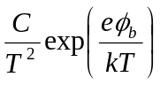 dependence of R_{s} dominates the temperature-independent resistance (R₀). This is further confirmed by considering the factors that contribute to R_{s} e.g. the grain size (large-grained samples have lower resistance) [12], the contribution of the TCO resistance (R_{s}  the square of the lateral length of the current path in the TCO) [13], and the thickness of the TCO [14]: In all these three cases, their contribution to R_{s}(T) is generally dominated by that of the back contact, as per equation 7.14. Further to this, it may be appreciated that errors in the measurement of R_{s} have a little impact on this temperature dependence, and do not therefore have a strong influence on the values of _{b} determined. This point was made in reference [7].

Investigation of materials and procedures for contacting CdTe solar cells

Introduction
This Section is concerned with using different materials for back contacting CdTe/CdS solar cells. Besides Au, which is the typical contact material for devices fabricated in research labs, both Sb₂Te₃ and As₂Te₃ were used to form back contacts. CdTe back surface was either a) non-treated i.e. as-grown, or b) etched with i) N-P solution (wet etching), or ii) plasma (dry etching) prior to application of the contact layer.

Experimental
Eleven contact types were investigated in this Section. 5×5 cm TEC 15 Pilkington glass served as a substrate for all samples. CdS was grown by CBD by the author at Cranfield University as explained in Section 4.2.1. Prior to CdTe growth, CdS was annealed in H₂ ambient as described in Section 5.3.2.1. CdTe was grown by the CSS technique under a static pressure of ~ 6 Torr of N₂, while the source temperature was kept at 605°C and the substrate temperature was varied in the range of 460 - 510°C. The resultant thickness of the CdTe film was ~3 µm. All the CdTe growth runs took place consecutively and used the same source material to enhance the reproducibly of samples.
Each 5×5 cm plate was cut into four identical quarters prior to treating the back surface (by either N-P wet etching or plasma dry etching) for contacting. As mentioned in Chapter 5, each sample was denoted by four digits, the first three together denote the plate number while the fourth denotes the quarter. The details of both wet and dry etching procedures are described in Section 4.3.1f. The back surface treatment was the same for three of the quarters from the same plate. However, an un-etched sample from each different plate was contacted with Au for comparison.
The Au contact was applied by thermal evaporation whereas As₂Te₃, Sb₂Te₃ were deposited by sputtering followed by metallization with Mo. For more details about the deposition procedures for each material see Section 4.3.1g. No annealing treatment was undertaken after depositing the contacts. Table ‎7.2 summarises both the etching methods and contact materials used for all samples.

Sample | Etching | Contact | T
574-2 | N-P | Au | RT
574-3 | None | Au | RT
576-2 | Plasma | 100 nm As₂Te₃ then 200 nm Mo | 300°C
576-3 | Plasma | 100 nm Sb₂Te₃ then 200 nm Mo | 300°C
576-4 | Plasma | Au | RT
578-1 | None | Au | RT
578-2 | N-P | 100 nm As₂Te₃ then 200 nm Mo | 300°C
578-4 | N-P | 100 nm Sb₂Te₃ then 200 nm Mo | 300°C
579-1 | None | Au | RT
579-2 | None | 100 nm As₂Te₃ then 200 nm Mo | 300°C
579-3 | None | 100 nm Sb₂Te₃ then 200 nm Mo | 300°C

Table ‎7.2: The contact and etching types for each sample investigated in this work. T represents deposition temperature of the contact, where RT means room temperature.

The contact size was controlled by a shadow mask, which has 5×5 mm square holes. The CdTe was scribed around each contact manually by using a scalpel in order to avoid edge effects i.e. collecting extra current from edges of the contact. Dark J-V-T characteristics were recorded for each back contact as explained in Section 7.3.2.2. Furthermore, Method I was used to determine _{b} as discussed in Section 7.3.3. PV performance for all cells was measured under an approximate AM1.5 spectrum at ~1000 Wm⁻².

Results and discussion
Figure ‎7.5 shows the fits of R_{s} values versus T to equation 7.14 for all samples. The values of _{b} obtained from the graphs are summarised in Table ‎7.3, along with the working parameters of the cells.

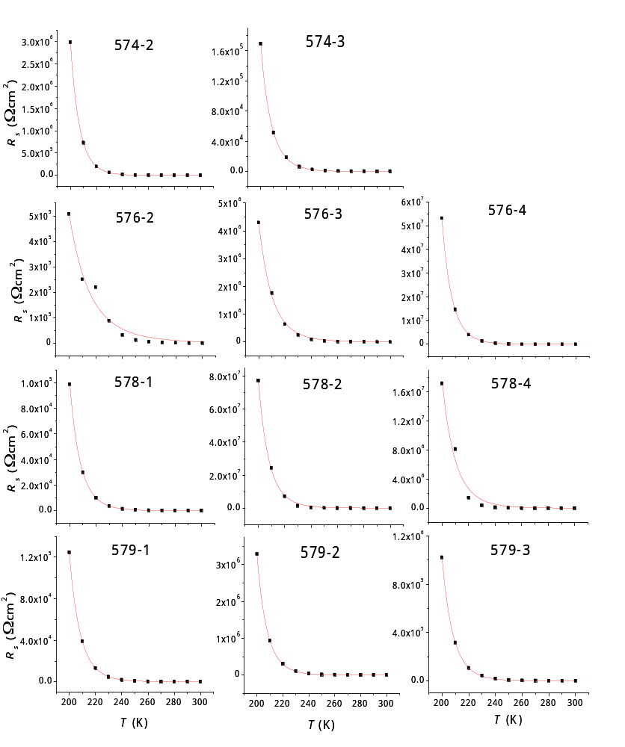

Figure ‎7.5: R_{s} vs. T for all contact types studied. The lines show the best fit to equation 7.14 using the barrier height _{b} as an adjustable parameter. Sample types are indicated on each graph by numbers – see Table ‎7.3 for details.

Sample | Etching | Contact | _{b}  (eV) | η  (%) | FF (%) | J_{sh}  (mA/cm²) | V_{oc}  (V)
574-2 | N-P | Au | 0.47 | 5.4 | 45.37 | 18.51 | 0.64
574-3 | No | Au | 0.39 | 4.4 | 44.19 | 15.35 | 0.65
576-2 | Plasma | 200 nm Mo/100 nm As₂Te₃ | 0.19 | 3.1 | 36.05 | 17.57 | 0.61
576-3 | Plasma | 200 nm Mo/100 nm Sb₂Te₃ | 0.31 | 1.3 | 25.44 | 9.1 | 0.58
576-4 | Plasma | Au | 0.44 | 1.9 | 25.06 | 15.92 | 0.48
578-1 | No | Au | 0.4 | 5.7 | 49.21 | 18.96 | 0.61
578-2 | N-P | 200 nm Mo/100 nm As₂Te₃ | 0.4 | 3.5 | 31.6 | 18.71 | 0.6
578-4 | N-P | 200 nm Mo/100 nm Sb₂Te₃ | 0.32 | 2.3 | 23.95 | 15.87 | 0.61
579-1 | No | Au | 0.39 | 5.6 | 48.79 | 19.22 | 0.6
579-2 | No | 200 nm Mo/100 nm As₂Te₃ | 0.42 | 5.4 | 41.47 | 21.61 | 0.6
579-3 | No | 200 nm Mo/100 nm Sb₂Te₃ | 0.39 | 3.6 | 29.35 | 20.37 | 0.6

Table ‎7.3: _{b} values and PV performance parameters for the samples listed in Table ‎7.2.

Control samples with Au/non-etched CdTe
The Au contact with no pre-etching was applied to samples grown in three separate CSS-runs and therefore acted as a control. These samples (574-3, 578-1 and 579-1) all gave barrier height of 0.39 ± 0.1 eV, demonstrating the reproducibility of contacting and of the measurement method. Furthermore, since the PV performance of the three cells varied by a factor of ~ 0.7, these measurements demonstrated that the barrier height measurement method is to some extent independent of the conversion efficiency. Hence the methodology of this work, i.e. to use non-optimised cells, is demonstrated to be a valid means of assisting the barrier height.

N-P and dry etching
As seen in Table ‎7.3 that both etching procedures (wet and dry, samples 574-2 and 576-4 respectively) acted to increase the barrier height of Au contacts in comparison with non-etched samples, the increase being from 0.39 to 0.47 and 0.44 eV respectively.
Plasma etching happens by “sputtering” layers from the CdTe back surface by bombarding it with Ar ions. The aim of this kind of etching is to remove oxide layers from CdTe surface before contacting. However, if damage resulting from plasma etching is severe, it may result in lowering FF and therefore η, of cells due to the plasma-induced damages on the surface. This damage forms defects in the contact/CdTe interface reducing carrier collection (that may occur due to carrier recombination via these defects), FF and η [15]. Plasma etching conditions (e.g. flux, temperature and time) are known to affect the resultant PV performance [15]. These conditions were not optimised in this study, which may lead to considerable damage for CdTe back surface.
Moreover, after plasma etching, the sample was removed from sputtering unit in order to evaporate Au in a thermal evaporator. This means that vacuum was broken and the sample was exposed to air, which may create oxides on the back surface of the device. Both factors, a) the surface damage due to etching, and b) the surface oxidation because of exposure of air, may act together to increase _{b} for sample 576-4 compared to other samples with Au contact and non-treated CdTe.
The effect of N-P etch on the cell performance, on the other hand, depends on: a) the exact composition of the etching solution [16], and b) the time of etching [6]. Proskuryakov et al. [6] reported that _{b} was reduced from 0.56 to 0.49 and 0.47 eV after etching in the same N-P solution used in this work for 5 and 10 seconds respectively, whereas it did not change with longer etching times up to 90 seconds. However, the timing procedure was different than that used in this work. While etching time started from immersing samples in the solution in this work, it started in Proskuryakov’s work after the creation of small bubbles on CdTe back surface. In the author’s experience, these bubbles take ~ 30 – 40 seconds to form, which means that the shortest actual etching time in Proskuryakov’s work was at least 35 seconds. Hence, the etching time used in this work (10 seconds) may be inadequate to remove oxides and form a Te-rich layer on the back surface of the cells.
Furthermore, the behaviour of Au contact on N-P etched sample could be due to water remaining in CdTe surface, which caused an increase in the barrier height. It is explained in Section 4.3.1f that samples were washed by DI water after N-P etching, prior to drying by N₂ in air. The presence of water on CdTe back surface may create oxide layers such as CdTe₂O₅, CdO [17] CdTeO₃ [15]. Ambient humidity is sufficient for formation of oxide layers which can increase the resistivity of CdTe surface [18], and may deteriorate the back contacts, and reduces FF [15]. Hence, the higher value of _{b} for Au with N-P etched sample may therefore be attributed to the existence of oxides on the back surface of CdTe, which may be created from the remaining water that only dry N₂ flow was insufficient to remove.

Sb₂Te₃ contact
The barrier height for Sb₂Te₃ contacts on non-etched CdTe (Table ‎7.3, sample 579-3) was the same as for Au on a non-etched surface. However, contrary to the case for Au, deposition on both wet- and dry-etched CdTe reduced the barrier height to 0.32 and 0.31 eV respectively.
Both Sb₂Te₃ contact and the subsequent Mo layer were deposited at T = 300°C as shown in Table ‎7.3. Hence, it can be speculated that any excess water left after N-P etch (as explained for the Au/N-P etched sample) was evaporated upon heating prior to application of the contact. This would eliminate the harmful effect of water on the back contact of CdTe cells as discussed above. On the other hand, plasma etching reduced the barrier height due to removing oxide layers from CdTe back surface. Both plasma etching and contacting were undertaken in the same unit i.e. without exposure to air. Plasma etching conditions used in this work is expected to induce surface damage (as in the case of Au contact), however, the deleterious effect of it seems to be insufficient to increase _{b} when it was not combined with the exposure to O₂-containing ambient.

As₂Te₃ contact
_{b} for the As₂Te₃ contact was 0.42 for non-etched, decreasing to 0.4 eV for the N-P etched cell (samples 579-2 and 578-2 in Table ‎7.3). The same argument (as that for Sb₂Te₃) can be made for As₂Te₃ since its deposition conditions were identical to those for Sb₂Te₃ i.e. the removal of excess water due to high deposition temperature of the contact may help forming a better contact than for room temperature metallization. However, for a plasma etched sample contacted with As₂Te₃ (sample 576-2), the barrier height was 0.19 eV, which is much lower than other contacts. This result may be inaccurate due to bad fit as shown in Figure ‎7.5. The reason of this behaviour is not clear and should be confirmed by repeating this run.

Comments on device performance
The performance of all devices varied significantly as seen in Table ‎7.3. However, this variation is inconsistent with the barrier height values. It was mentioned in Section 7.1 that high _{b} may affect only FF but not V_{oc} or J_{sc}. Nevertheless, these two parameters (i.e. V_{oc} and J_{sc}) did vary for these samples – for example, V_{oc} varied from 0.65 V to 0.48 V (samples 574-3 and 576-4) while J_{sc} varied from 21.61 mA/cm² to 9.1 mA/cm² (samples 579-2 and 576-3). This implies that the back contact was not the only limiting factor for PV performance.
Performance may vary across the same sample for several reasons such as thickness uniformity of layers, pinholes and heat distribution during CdCl₂ treatment. More variation may occur for samples with either Sb₂Te₃ or As₂Te₃ contacts due to the contact deposition temperature (= 300°C) compared to Au contact-based samples which was deposited at room temperature i.e. the additional heat treatment for Sb₂Te₃ and As₂Te₃ contact-based cells may be itself non-uniform. FF may change due to changes in R_{s} that can occur from various origins as discussed in Section 7.3.3, which means that FF need not depend only on _{b}. The effect of the barrier height may be dominated by the effects of other factors, which resulted in the inconsistency of the performance with variation in _{b}.
By comparing all values of _{b} in Table ‎7.3, it can be concluded that Sb₂Te₃ is a promising back contact for CdTe devices, although the PV performance for cells contacted with it happened to be poorer in comparison with other cells. The performance of cells contacted with Sb₂Te₃ depends on the thickness, deposition temperature, sputtering power and post-growth annealing for back contact (both Sb₂Te₃ and Mo) [15]. In addition, dry etching can affect the performance of cells depending on its ambient, power and time [15]. More runs are needed to optimise both a) its growth conditions, and b) etching conditions in order to improve the performance of cells.

Conclusion
This Chapter started with describing the problematic feature of the CdTe contact, which occurs due to the fact that the electron affinity of CdTe is sufficiently high that there is no metal that may satisfy the equation, i.e. capable of making an Ohmic contact with CdTe. High resistive (rectifying) contacts may have a deleterious effect on the conversion efficiency of solar cells. The techniques commonly used to overcome this issue were outlined in Section 7.1.
Five methods of determining the back contact barrier height _{b} were described briefly in Section 7.2, from which the most applicable and accurate two methods were selected (Methods I and III). However, slight modifications were applied to both methods in order to obtain more accurate results (Section 7.3.1). A preliminary study was performed on three CdTe cells having different contacts to compare their results with each other, and therefore test the reliability of the results. Both methods (Methods I and III) gave similar results for _{b} with an error of ± 0.01 eV, leading to the conclusion that the determined values of _{b} are valid. Nevertheless, Method I was chosen to determine _{b} for other contacts in this Chapter due to its higher applicability compared to Method III (which is applicable only if the roll-over effect appears in the J-V curve). In addition, the results obtained from the preliminary study showed that the barrier height is independent of a) PV performance of the cell, b) contact size and c) contact geometry.
The barrier height of contacts made with three materials (Au, Sb₂Te₃ and As₂Te₃) was investigated in Section 7.4, each material being combined with either N-P or plasma etching or else without pre-treatment. A set of three control samples (Au/non-etched CdTe) was investigated, and showed good reproducibility of the results (_{b} = 0.39 ± 0.01 eV). Both wet and dry etching increased _{b} for Au contacts (_{b} = 0.47 eV and 0.44 eV respectively). Water adsorbed on the CdTe (due to cleaning following the N-P etching) was speculated to create oxides on the CdTe back surface, leading to higher values _{b} in comparison with _{b} values of the control samples. On the other hand, the combination of a) surface damage that may be created from a severe plasma etching, and b) the possible formation of oxides (due to breaking vacuum during contacting process) may be responsible of deteriorating the contact in the case of the plasma-etched sample.
The behaviour of the Sb₂Te₃ contacts differed from that of Au contacts although _{b} for both contacts (i.e. Au and Sb₂Te₃) with non-etched CdTe was similar. The improvement of the Sb₂Te₃ contact by N-P etching may be attributed to the evaporation of any excess water present on the CdTe as the contact deposition took place at T = 300°C. The fact that Sb₂Te₃ was sputtered directly after plasma etching of CdTe may suggest that the etching-induced surface damage was inadequate to increase _{b} in the absence of exposing the sample to an O₂-contanig ambient before applying the contact.
The reason for the slight improvement of the As₂Te₃ contact with N-P etching compared to the non-etched one may be similar to that of Sb₂Te₃ contact i.e. evaporation of water during contacting. However, the bad fit of the data of As₂Te₃/plasma-etched sample to equation 7.14 (see Figure ‎7.5) may have resulted in an erroneous value of _{b}, which therefore needs to be verified by further tests.
PV performance varied from a sample to another, with the variation being inconsistent with the values of the barrier height. The variation in performance among samples could be due to a) non-uniformity across each 5×5 cm plate, and b) irreproducibility of both growth runs and CdCl₂ treatment rather than the barrier height.
Finally, Sb₂Te₃ contacts gave the lowest barrier height among all other contacts, which implies that it can be a promising contact candidate for CdTe solar cells. However, a precise conclusion about the performance of this contact needs further tests in order to optimise its a) most suitable pre-growth treatment, b) growth conditions, and c) post-growth thermal treatment.

References for Chapter 6

[1] G. Stollwerck and J.R. Sites, in 13th European PVSEC, Nice, France, (1995), 2020-2023.
[2] A. Niemegeers and M. Burgelman, Journal of Applied Physics 81 (1997) 2881-2886.
[3] J. Pan, PhD Thesis, Colorado State University, Fort Collins, (2007).
[4] A. W. Brinkman. in (P. Capper, Ed.) Properties of Narrow Gap Cadmium-based Compounds, INSPEC, the institution of Electrical Engineers, London (1994).
[5] D. L. Bätzner, M. E. Oszan, D. Bonnet and K. Bucher, Thin Solid Films 361-362 (2000) 288-292.
[6] Y. Y. Proskuryakov, K. Durose, B. M. Taele, G. P. Welch and S. Oelting, Journal of Applied Physics 101 (2007) 014505.
[7] Y. Y. Proskuryakov, K. Durose, B. M. Taele and S. Oelting, Journal of Applied Physics 102 (2007) 024504.
[8] G. Koishiyev, J. R. Sites, S. S. Kulkarni and R. G. Dhere, in 33rd IEEE Photovoltaic Specialist Conference, San Diago, CA, USA, (2008).
[9] B. E. McCandless, J. E. Phillips and J. Titus, in 2nd World PV Conf, (1998), 448-452.
[10] S. H. Demtsu and J. R. Sites, Thin Solid Films 510 (2006) 320-324.
[11] G. Stollwerck, MSc Thesis, Colorado State University (1995).
[12] J. Major, PhD Thesis, Durham University, Durham, (2008).
[13] G. T. Koishiyev and J. R. Sites, Solar Energy Materials and Solar Cells 93 (2009) 350-354.
[14] N. Romeo, A. Bosio, R. Tedeschi and V. Canevari, Thin Solid Films 361-362 (2000) 327-329.
[15] V. Viswanathan, PhD Thesis, University of South Florida, Tampa, FL, USA, (2004).
[16] D. L. Bätzner, R. Wendt, A. Romeo, H. Zogg and A. N. Tiwari, Thin Solid Films 361-362 (2000) 463-467.
[17] B. E. McCandless and K. D. Dobson, Solar Energy 77 (2004) 839-856.
[18] H. R. Moutinho, R. G. Dhere, C.-S. Jiang, M. M. Al-Jassim and L. L. Kazmerski, Thin Solid Films 514 (2006) 150-155.

